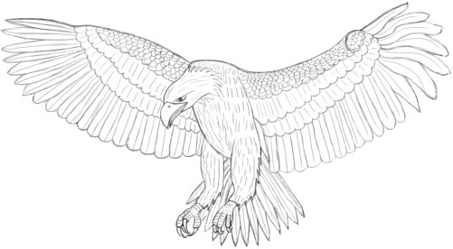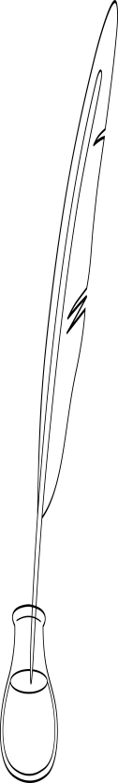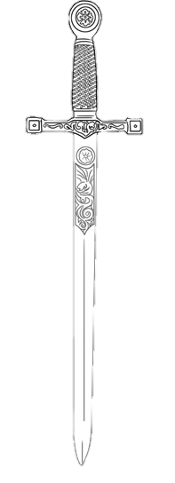

**Citadel**

**For success, only vote for the best**

**TATIANA MONTES FOR PRESIDENT**



**Citadel**

**For success, only vote for the best**

**TATIANA MONTES FOR PRESIDENT**

