Childhood
By: Skyler Lowman

Everyone has his or her own childhood,
But everyone shares a couple memories.

Remember your favorite toy,
And how it had to go everywhere with you.
You struggled to let it go when you had to leave it.

Remember how you went to Disney World,
You met your favorite character,
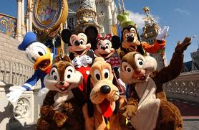
And you had to get their autograph.
You thought of them like a celebrity.

Remember the first time it snowed,
How excited you were.
You wanted to make a snowman,
But you were too young to know how.

Remember when you went to a fancy hotel,
Over everything there was to do,
The only thing that interested you
Was jumping on the bed.

Remember drawing on the car windows
Through the condensation,
Thinking about how everyone
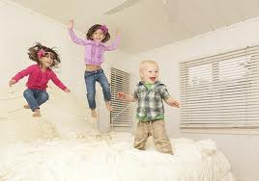
Would be looking at it.

Remember your best friend,
The one who was always over at your house,
And did everything with you.
And when no one else could come over,
They always could.

Remember your dog,
Always wanting to hang out with them,
And calling them,
So that they would sleep in your room.

Remember enjoying everything,
And appreciating the littlest things so much.
Just living life to the fullest,
That was my childhood.

