Haiku- Flower
By: Mohammad Akmal Nazir

Hanging on the branch
Scattering fragrance all around it
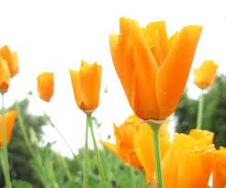
Leaving us enthralled.
