Limerick - ' Fly'
By Godfrey Morris
A fly flew
And then got slew
Said the fly 'why'
Said I 'want you die'
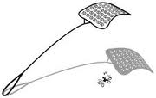
And the fly got the clue

