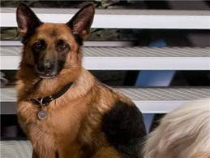
Logan Thibault
By: Skyler Lowman 6A 9/16/12
Character: Logan Thibault from The Lucky One
Logan
Caring, adventurous, romantic, and brave
Relative of Zeus
Who loves Beth, Ben, and his dog
Who feels happy to be serving his country, lucky to have survived war and have met Beth, and sorry for Bet losing Derek
Who needs time to explain why he came to see Beth, to fix the boat, and to save Ben
Who fears getting killed in war, losing Ben and Beth, and Beth getting hurt by Keith
Who gives care towards Ben and Beth, his time to be with Beth, his talent towards the church by playing the Organ at services
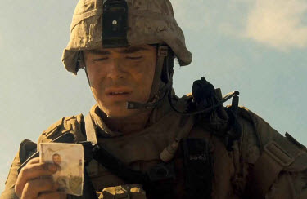
Who would like to see Ben grow up, Beth with full custody, and to see the boat fixed
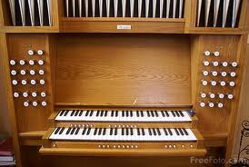
Who is a risk-taker and a critical thinker
Who inspires Ben
Resident of North Carolina
Thibault

