SYMBOL:

Citadel means protection which is why we chose it. We believe that the protection of citizen’s safety and rights is important so we based our name and symbol off of this. The symbol includes an eagle holding a sword and a pen in the other foot. The eagle is representing our patriotism and how we will always be loyal to democracy and America. The sword the eagle is holding represents us protecting the citizen’s safety with national/ local defense. The pen represents us protecting the citizen’s rights. The eagle is holding these to show that we believe that these are important parts of our nation, and we will never let go of these things. The background is shaded just to add effect. And there are stars to represent how we understand the responsibility of watching over many citizens (play off of too many stars to count).

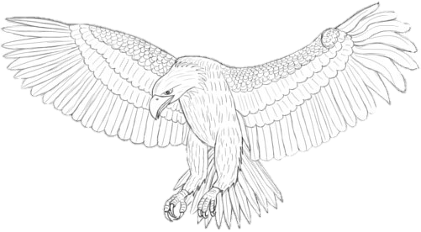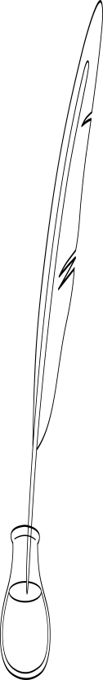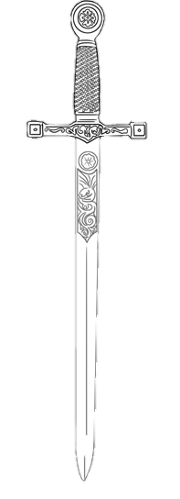

**Citadel**