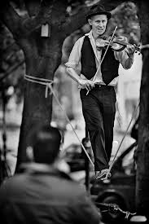
The Picture- A Ballad:
By: Skyler Lowman

It was summer when I found it,
It was a picture in black and white
It had a man in it,
I had never seen him before;
He was a portly man,
With a nice, dark, long beard.

I was in my room,
Analyzing him,
Trying to think if I had seen him before
I thought his eyes looked like mine;
Deep green, with a blue spec.
I wondered if he was my father.
My father died before I was born;
In a car accident
But this man was much younger than 24;
That’s the age my father died.
This man looked to be about 15.

Maybe it was my father,
My mother knew him best,
So why not ask her?

I brought the picture down to her,
The second she saw the tall, big man,
She looked at me with a death stare,
I asked if it was my father,
I waited forever for a response!

My mother, with tears in her eyes
Turned to me and hit me!
She had never hit me before!
She turned to me and said
“I have never seen this man before!”
I knew she was lying,
And I knew it was my father.

