Today
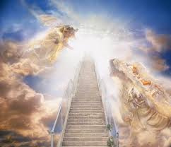
By: Skyler Lowman

Today is the day,
I will open my eyes.

I will see His eyes,
As blue as the sea,
I will see his love to the unloved,
And I will see his faithfulness.

I have been dreaming about this time,
When it was in my near future,
A place where there are no white lies
And everything is perfect.

Now that I am here,
I can see God greet great people,
And, amazingly,
I am now included within that category!

Today is the day,
I have opened my eyes,
And witnessed eternal life.
